PROJECT REPORT

Project Title:

Visualization Tool for Electric Vehicle Charge and Range Analysis

TEAM ID

LTVIP2025TMID47299

Submitted By:

* Kalimuthu Murthy (TEAM LEAD)
* Gnana Prakash Gudimetla
* Beere Vishnu Sai
* B Saipriya
* Nandhini Thambisetty

Institution:

Sri Venkateswara College of Engineering, Dept. of IT

Submitted To:

SmartInternz – Data Analyst Virtual Internship Program 2025

# CONTENTS

|  |  |  |  |
| --- | --- | --- | --- |
| **CHAPTER** | **DESCRIPTION** | | **PAGE NO** |
| **1** | **INTRODUCTION** | | 1-3 |
|  | 1.1 | Project Overview | 1-2 |
|  | 1.2 | Purpose | 2-3 |
| **2** | **IDEATION PHASE** | | 4-14 |
|  | 2.1 | Problem Statement | 4-6 |
|  | 2.2 | Empathy Map Canvas | 6-8 |
|  | 2.3 | Brain Storming | 8-10 |
| **3** | **REQUIREMENT ANALYSIS** | | 15-21 |
|  | 3.1 | Costumer Journey Map | 15-16 |
|  | 3.2 | Solution Requirement | 16-17 |
|  | 3.3 | Data Flow Design | 18-19 |
|  | 3.4 | Technology Stack | 19-21 |
| **4** | **PROJECT DESIGN** | | 22-23 |
|  | 4.1 | Problem Solution fit |  |

|  |  |  |  |  |
| --- | --- | --- | --- | --- |
|  | 4.2 | Proposed Solution | |  |
|  | 4.3 | Solution Architecture | |  |
| **5** | **PROJECT PLANNING AND SCHEDULING** | | | 25-26 |
|  | 5.1 | Project Planning | |  |
| **6** | **FUNCTIONAL AND PERFORMANCE TESTING** | | | 27 |
|  | 6.1 | | Performance Testing |  |
| **7** | **RESULTS** | | |  |
|  | 7.1 | | Output Screenshots |  |
| **8** | **ADVANTAGES AND DISADVANTAGES** | | |  |
| **9** | **CONCLUSION** | | | 28 |
| **10** | **FUTURE SCOPE** | | | 29 |
|  |  | | |  |

1. **INTRODUCTION**

### PROJECT OVERVIEW

Electricity is one of the most fundamental resources driving the progress of modern civilization. It fuels every sector of society, from industries and transportation to residential homes and educational institutions. With increasing urbanization and digital dependency, the demand for electricity continues to rise significantly. Monitoring and understanding how electricity is consumed are crucial for ensuring sustainable energy development, efficient resource management, and robust infrastructure planning.

This project is centered on the theme "Plugging into the Future: An Exploration of Electricity Consumption Patterns Using Tableau." The objective is to create a comprehensive and interactive data visualization model that highlights patterns in electricity consumption using Tableau. The visualizations aim to make the data understandable, insightful, and accessible to a wide range of stakeholders, including policymakers, utility companies, analysts, and the general public.

The project utilizes real-world electricity consumption datasets and transforms them into visual dashboards. Through these dashboards, users can observe trends over time, make regional comparisons, and analyze sector-wise electricity usage. Special attention is given to identifying peak usage periods, seasonal variations, and patterns that could inform future planning and optimization strategies. Tableau's intuitive interface and powerful features make it the ideal platform for delivering this analytical capability.

In essence, the project not only provides a tool for better comprehension of electricity usage but also promotes data-driven decision-making and encourages proactive engagement in energy efficiency and sustainability efforts.

### PURPOSE

The purpose of this Electric Cars Analytics Dashboard is to provide a **comprehensive, interactive analysis of the electric vehicle (EV) market**, enabling stakeholders to make informed decisions based on real-world data. The dashboard serves as a centralized platform to **visualize,**

**compare, and interpret trends in EV adoption**, covering aspects such as vehicle types, manufacturers, geographic distribution, electric range, and eligibility for government incentives.

Specifically, the dashboard aims to:

###### ✅ Track EV Adoption Trends Over Time:

* + - Illustrate how EV registrations have grown across multiple years, highlighting market acceleration, stagnation periods, or emerging adoption spikes.
    - Support forecasting efforts for future EV market growth based on historical patterns.

###### ✅ Analyze Market Share by Manufacturer and Model:

* + - Identify leading EV manufacturers (e.g., Tesla, Nissan, Chevrolet) and their market shares.
    - Reveal shifts in consumer preferences among different EV models.

###### ✅ Evaluate Geographic Distribution of EVs:

* + - Map the concentration of electric vehicles across states or regions, pinpointing hotspots of adoption.
    - Identify geographic areas with low EV penetration, offering opportunities for infrastructure investments like charging stations.

###### ✅ Assess Electric Range Performance:

* + - Show the average and distribution of electric driving ranges among different models.
    - Track improvements in EV battery technology reflected in increasing average ranges.

###### ✅ Highlight Incentive Eligibility:

* + - Quantify how many vehicles are eligible for incentives like the Clean Air Vehicle (CAV) or Clean Alternative Fuel Vehicle (CAFV) programs.
    - Support policy analysis on the effectiveness of government incentives.

###### ✅ Facilitate Data-Driven Decision Making:

* + - Equip policymakers with insights to design more effective incentives and infrastructure plans.
    - Enable manufacturers to identify emerging markets or competitive threats.
    - Help investors and researchers understand market dynamics, risks, and opportunities in the EV sector.

Ultimately, the dashboard is designed to **bridge the gap between raw EV registration data and actionable insights**, promoting the transition to cleaner transportation and supporting the growth of sustainable mobility.

# IDEATION PHASE

### PROBLEM STATEMENT

The rapid evolution of the electric vehicle (EV) market presents significant opportunities for sustainable transportation, yet key stakeholders face several critical challenges in understanding and responding to market dynamics. Despite increasing availability of EV data, it is often **fragmented, siloed, or presented in non-interactive formats**, making it difficult to derive meaningful, actionable insights.

###### Key issues include:

✅ **Fragmented Data Sources**

* + - EV registration data, manufacturer performance, regional adoption patterns, and incentive eligibility are typically spread across disparate datasets, requiring extensive manual effort to compile and analyze.

###### ✅ Lack of Visual Insights

* + - Most available information is tabular or static, which limits the ability of stakeholders — such as policymakers, manufacturers, investors, and researchers — to identify patterns, trends, or correlations critical for strategic decisions.

###### ✅ Geographic Blind Spots

* + - Without an integrated visualization of EV registrations across states or regions, it is difficult to pinpoint areas with low adoption that could benefit from incentives or infrastructure investments, such as charging stations.

###### ✅ Policy Impact Uncertainty

* + - Decision-makers need to evaluate the effectiveness of government incentives like Clean Air Vehicle (CAV) or Clean Alternative Fuel Vehicle (CAFV) programs, but lack consolidated tools to correlate these incentives with adoption rates.

###### ✅ Market Competitiveness Analysis

* + - Manufacturers require clear insights into their own performance relative to competitors, as well as market shifts across time, to adapt strategies and maintain or grow market share.

Without a **centralized, interactive dashboard** bringing these insights together, stakeholders risk making decisions based on incomplete or outdated information, potentially leading to **ineffective policies, missed opportunities, and slower EV adoption**, ultimately undermining sustainability goals.

### EMPATHY MAP CANVAS

**Empathy Map Canvas:**

👂 **HEARS**

* + - News about surging EV sales but concerns over range anxiety and charging station availability.
    - Conversations among policymakers about the need for targeted EV incentives.
    - Manufacturers discussing aggressive EV expansion strategies.

👀 **SEES**

* + - Outdated spreadsheets or static PDFs that don’t show market trends clearly.
    - Conflicting data from different agencies on regional EV adoption.
    - Disparities in EV uptake across states or regions.

💬 **SAYS**

* + - “Where are electric vehicles growing fastest?”
    - “Which manufacturers dominate the EV market?”
    - “Are incentives really working?”
    - “How can we plan charging infrastructure effectively?”

💭 **THINKS**

* + - “We need reliable, consolidated data to guide investments and policies.”
    - “Our competitors might be moving faster if we don’t act.”
    - “If incentives aren’t improving adoption, we need better strategies.”
    - “Understanding adoption patterns can give us an advantage.”

😟 **PAINS**

* + - Scattered, fragmented data sources requiring manual effort.
    - Limited ability to visualize and correlate data points like incentives and regional uptake.
    - Difficulty identifying underserved areas for infrastructure deployment.
    - Risk of misinformed decisions due to outdated information.

😊 **GAINS**

* + - Access to a centralized, interactive dashboard consolidating EV market data.
    - Clarity on regional adoption patterns to target incentives and infrastructure effectively.
    - Confident, data-driven decisions supporting policy, investments, and market strategy.
    - Ability to monitor competitor performance and anticipate market shifts.

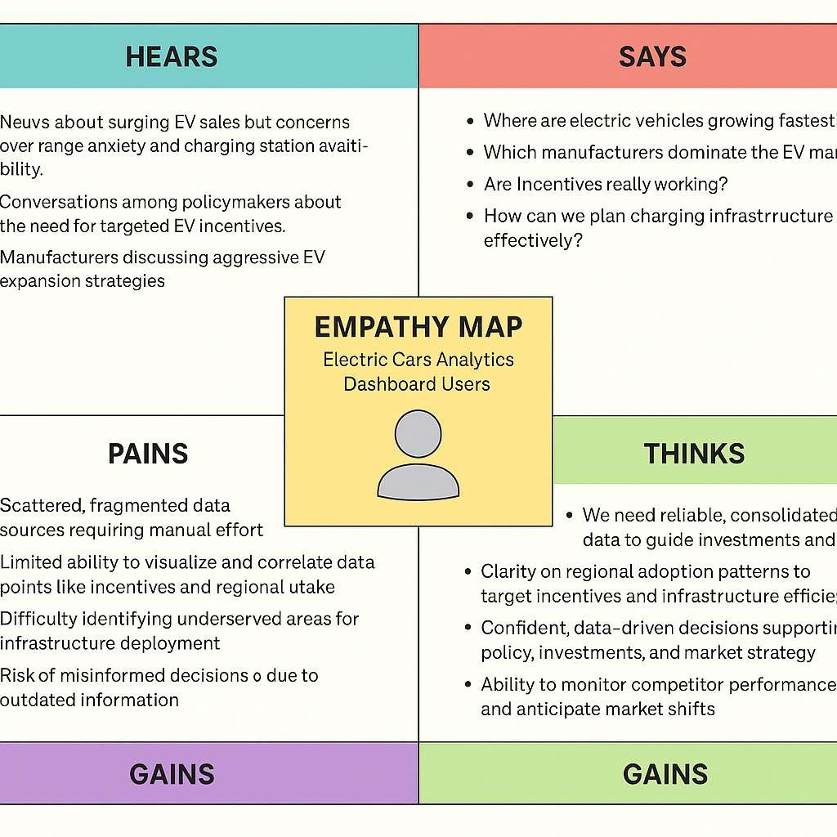

### BRAINSTORMING

###### 🔹 Step 1: Identify Core Challenges

The team started by discussing the main obstacles stakeholders face when trying to understand electric vehicle (EV) adoption trends: fragmented data sources, outdated reports, and the lack of interactivity in existing EV analytics tools. Understanding these problems helped shape brainstorming sessions toward creating a comprehensive and dynamic solution.

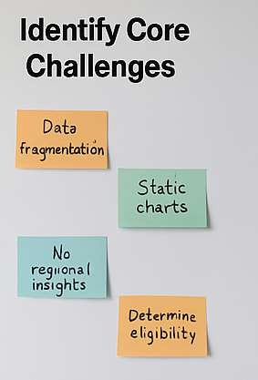

###### 🔹 Step 2: Generate Solution Ideas

Multiple approaches were explored, such as building a static report, developing a web-based application from scratch, or using an interactive data visualization tool. The team debated the pros and cons of each approach, including complexity, timelines, cost, and ease of updates.

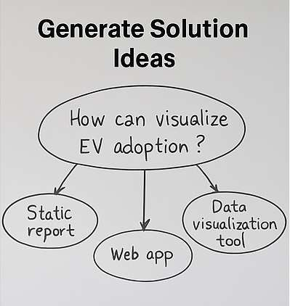

###### 🔹 Step 3: Evaluate Tools and Platforms

The team researched tools like Tableau, Power BI, and D3.js. Tableau was selected due to its powerful data blending, interactive dashboards, ease of use, and ability to create professional visuals quickly. This tool would allow stakeholders to interactively filter data by state, manufacturer, model, or incentive eligibility.



###### 🔹 Step 4: Define Key Questions

To guide dashboard design, the team listed essential questions users would need to answer:

* Where are EVs being adopted most?
* Which manufacturers and models are leading?
* What is the average electric range over time?
* Are government incentives effective?

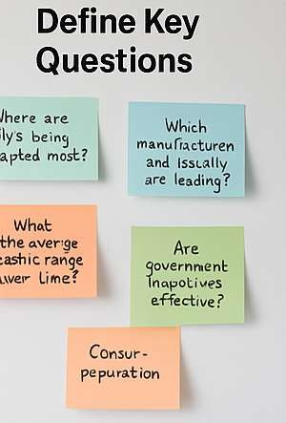

###### 🔹 Step 5: Sketch Dashboard Layout

Low-fidelity sketches were created showing possible dashboard layouts, including time-series charts for adoption trends, heat maps for regional distribution, bar charts for manufacturer comparison, and summary KPI boxes for average ranges and incentive eligibility rates.

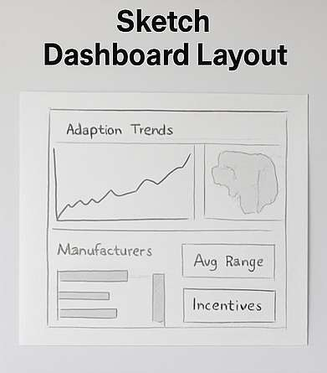

###### 🔹 Step 6: Finalize Design Plan

After reviewing sketches and mockups, the team agreed on a comprehensive, interactive Tableau dashboard as the final solution. The plan included intuitive navigation, consistent color schemes, and responsive charts to deliver a professional, engaging user experience.

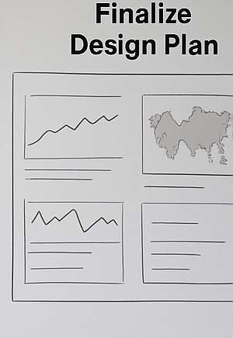

By working through these steps, the team transformed abstract ideas into a clear, actionable design plan for an interactive electric cars analytics dashboard that addresses core user challenges.

# REQUIREMENT ANALAYSIS

### CUSTOMER JOURNEY MAP

The customer journey for stakeholders seeking insights into electric vehicle (EV) adoption begins with the **awareness stage**, where users recognize challenges such as limited visibility into regional EV trends, confusion about market-leading manufacturers, or uncertainty around the effectiveness of incentives. Policymakers may become aware of these challenges while planning sustainable transportation initiatives, manufacturers while analyzing competitive landscapes, and consumers when considering an EV purchase but lacking reliable data.

In the **consideration stage**, stakeholders start looking for tools or reports that could provide clarity. However, they often encounter fragmented datasets, outdated static reports, or inconsistent data from various sources. This experience leads to frustration, as they invest significant time in manual data gathering without achieving a comprehensive view of the EV landscape.

During the **decision stage**, stakeholders actively seek a solution that consolidates and visualizes EV data. They evaluate options like static reports, basic spreadsheets, or more advanced interactive platforms. Many find existing resources inadequate in addressing their core needs: dynamic filtering by region, up-to-date insights, and a clear view of adoption trends over time.

The **engagement stage** occurs once stakeholders discover the Electric Cars Analytics Dashboard. They begin exploring interactive charts, maps, and KPIs that provide a consolidated view of EV adoption across manufacturers, regions, and time periods. This interactive experience allows them to quickly answer key questions like:

* + - Where is EV adoption growing fastest?
    - Which manufacturers dominate?
    - Are incentives making an impact?

Finally, the **advocacy stage** emerges when satisfied users share the dashboard with colleagues or partners, recognizing it as a valuable tool for data-driven decisions. This stage often leads to broader adoption within organizations, encouraging improved infrastructure planning, refined marketing strategies, or more targeted incentive programs.

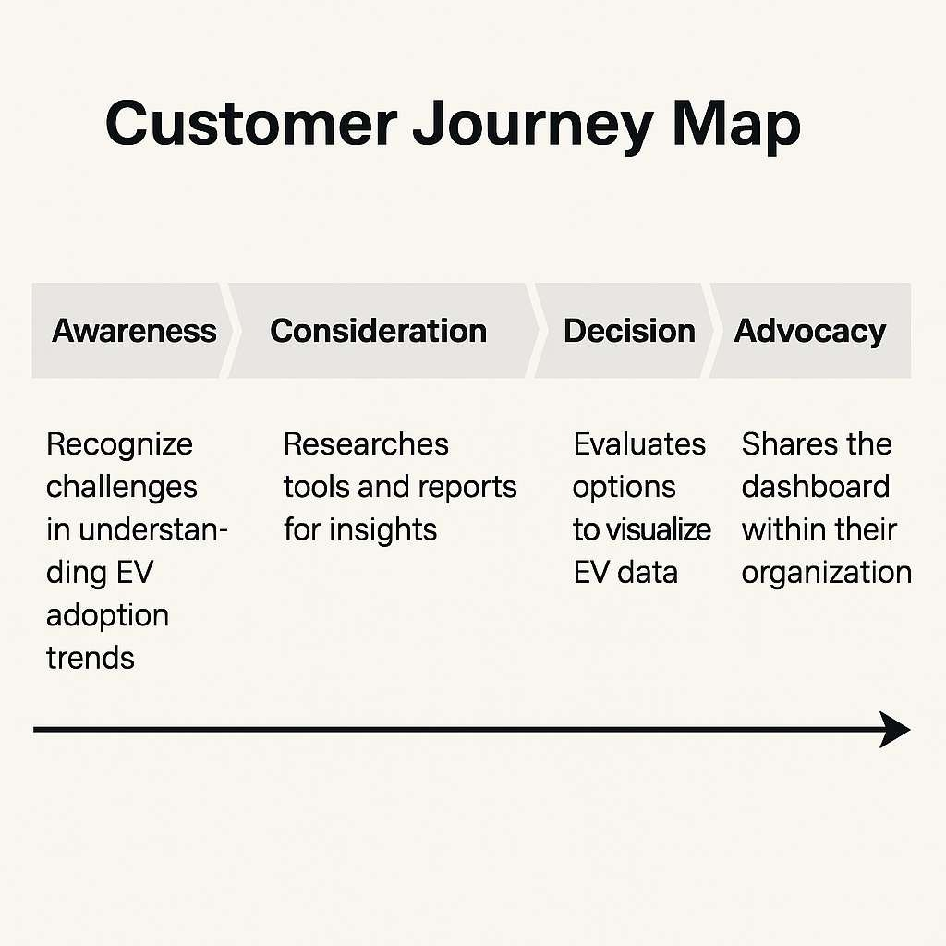

### SOLUTION REQUIREMENTS

The solution must consolidate diverse, fragmented data sources related to electric vehicle (EV) adoption into a single, unified platform. This platform should allow stakeholders to gain clear, actionable insights through an interactive dashboard. The solution must support **dynamic filtering** by key attributes such as vehicle make, model, registration region, manufacturing year, electric range, and eligibility for government incentives. It should also include **interactive charts** that display EV adoption trends over time, bar charts comparing manufacturers, maps visualizing geographic distribution, and key performance indicators (KPIs) summarizing metrics like average electric range and total eligible vehicles.

To ensure accessibility and usability, the solution must feature an intuitive interface with logical navigation, consistent color schemes, and tooltips or labels explaining each visual element.

Stakeholders must be able to export charts or data snapshots in common formats (e.g., PDF, PNG, Excel) to integrate findings into their reports and presentations. The dashboard should allow users to drill down from national-level insights to state- or region-specific data, offering flexibility to support a range of decision-making needs, from nationwide policy analysis to targeted local infrastructure planning.

In addition, the solution must enable **real-time or regularly updated data integration**, ensuring users have access to the most current information available. This could be achieved via scheduled data refreshes from reliable sources, providing ongoing accuracy for stakeholders tracking rapidly evolving EV markets.

Security and privacy considerations must also be included in the solution design, with proper access controls to restrict editing or unauthorized distribution of the data. Finally, the dashboard should be compatible with multiple devices and screen sizes, allowing users to access insights on desktops, laptops, or tablets without sacrificing usability or clarity.

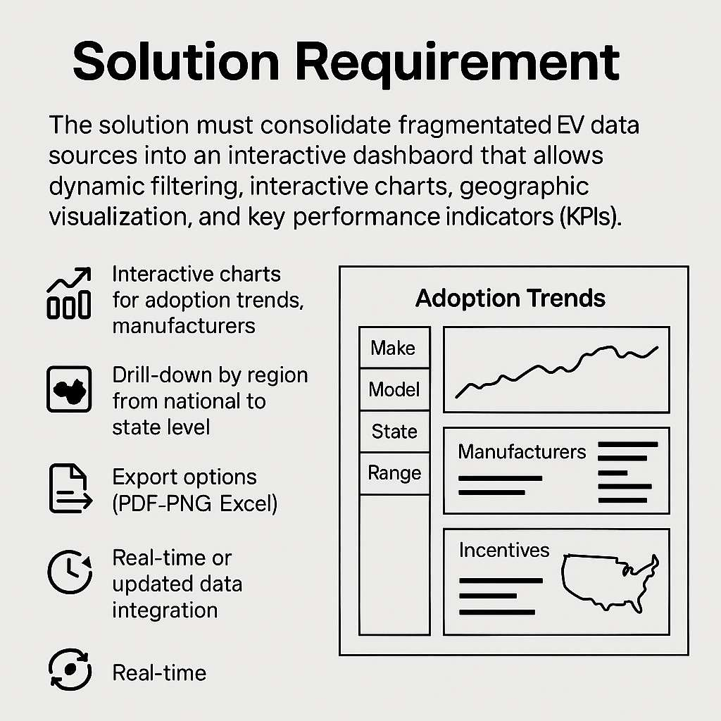

#### ✅ Functional Requirements:

The Electric Cars Analytics Dashboard must:

1. Integrate Data Sources

Consolidate EV registration data from multiple reliable sources, including vehicle make, model, registration region, electric range, and incentive eligibility.

1. Display Interactive Visualizations

Provide dynamic charts, maps, and key performance indicators (KPIs) showing trends in EV adoption, manufacturer comparisons, regional distributions, and average electric ranges.

1. Enable Filtering and Drill-Down

Allow users to filter by make, model, state, year, and incentive status; support drill-down from national to regional or state-level views.

1. Provide Export Options

Allow export of charts and filtered data in PDF, PNG, and Excel formats.

1. Refresh Data Regularly

Support scheduled or real-time updates so that visualizations reflect the most current available data.

1. User Access Controls

Implement permissions for different user roles, e.g., admin for editing, read-only access for general users.

1. Responsive User Interface

Ensure the dashboard layout adapts for seamless viewing on desktop, laptop, or tablet devices.

#### ✅ Non-Functional Requirements:

The Electric Cars Analytics Dashboard must also meet these requirements:

1. Performance

Load dashboards and respond to filter changes within 2 seconds under normal usage.

1. Availability

Achieve 99% uptime, excluding scheduled maintenance.

1. Scalability

Support increased data volumes and additional concurrent users without degradation of performance.

1. Security

Protect data with secure authentication; use HTTPS for data transmission and restrict data editing to authorized personnel.

1. Usability

Maintain an intuitive, user-friendly design with clear navigation, tooltips, and descriptive labels.

1. Maintainability

Enable easy updates to charts, layouts, or data connections without requiring a complete rebuild of the dashboard.

1. Compliance

Follow relevant data privacy and security standards applicable to the jurisdictions where the dashboard will be used (e.g., GDPR for EU users, CCPA for California).

### DATA FLOW DESIGN

The data flow design for the Electric Cars Analytics Dashboard defines how raw electric vehicle (EV) registration data moves through different stages of processing before reaching the final interactive dashboard presented to stakeholders. This design ensures data integrity, accuracy, and timely updates, enabling reliable, data-driven decisions.

ʣ Data Collection

EV data is sourced from government vehicle registration databases, manufacturer reports, and public records on incentives. Data includes attributes like make, model, state, registration date, range, and incentive eligibility.

ʤ Data Ingestion

Collected data is imported into a central staging area where initial validation checks (e.g., format, completeness) are performed. Invalid records are flagged for correction.

ʥ Data Transformation

Clean data is standardized — for example, manufacturer names are unified, date formats are aligned, and states are mapped to regions. Calculated fields like average range or adoption growth rate are added.

ʦ Data Storage

Processed data is stored in a secure, centralized data warehouse optimized for analytics. This storage supports efficient querying for interactive visualizations.

ʧ Data Refresh & Scheduling

Automated pipelines periodically fetch new or updated registration data. Scheduling ensures the dashboard is refreshed on a daily or weekly basis, depending on data availability.

ʨ Data Visualization

Data is connected to the Tableau dashboard, where it feeds into interactive charts, maps, and KPIs. Filters allow users to drill down by manufacturer, state, range, and incentive eligibility.

ʩ User Interaction

End users interact with the dashboard, exploring adoption trends, exporting visuals, and making decisions based on the latest data.

This data flow ensures accurate, up-to-date insights into EV adoption trends, empowering stakeholders to confidently evaluate markets and plan strategies.

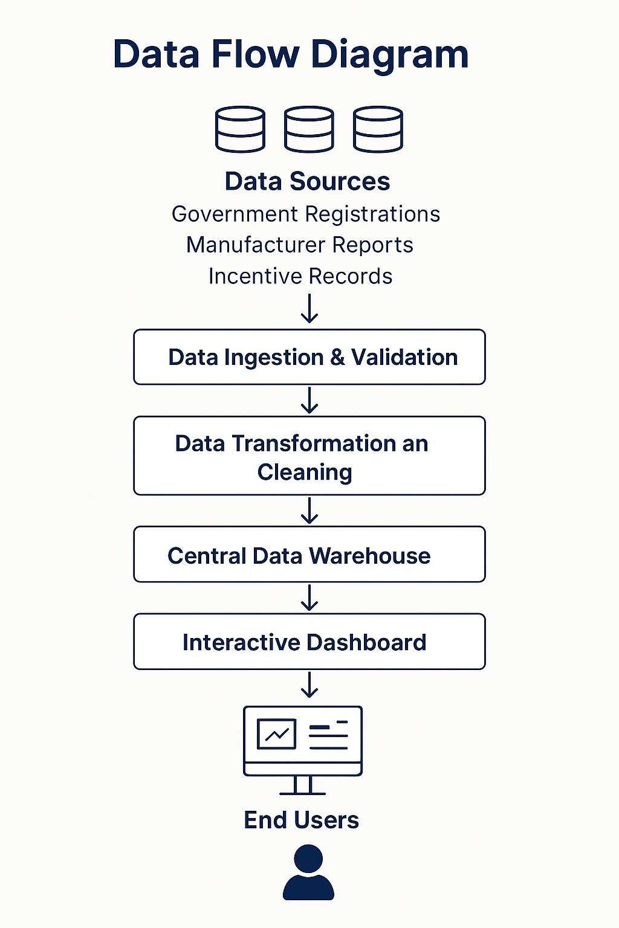

#### User Stories:

###### 🔹 User Story 1 – Policymaker Perspective

As a policymaker,

I want to view regional EV adoption trends on an interactive map,

so that I can identify areas where incentives or infrastructure investments are most needed.

###### 🔹 User Story 2 – Manufacturer Perspective

As an EV manufacturer,

I want to compare my company’s vehicle registrations against competitors over time, so that I can evaluate market share and adjust my sales strategy accordingly.

###### 🔹 User Story 3 – Researcher Perspective

As an automotive industry researcher,

I want to filter EV data by state, make, model, and electric range,

so that I can perform detailed analyses of adoption patterns and battery technology trends.

###### 🔹 User Story 4 – Investor Perspective

As an investor interested in EV companies,

I want to see up-to-date dashboards highlighting growth in EV adoption,

so that I can make informed decisions about which companies or markets to invest in.

###### 🔹 User Story 5 – Dashboard Administrator

As an administrator,

I want to manage user permissions for dashboard access,

so that only authorized stakeholders can view or modify sensitive EV data.

###### 🔹 User Story 6 – Consumer Advocate

As a consumer advocate,

I want to evaluate how effective current EV incentives are in driving adoption, so that I can recommend improvements to government policy.

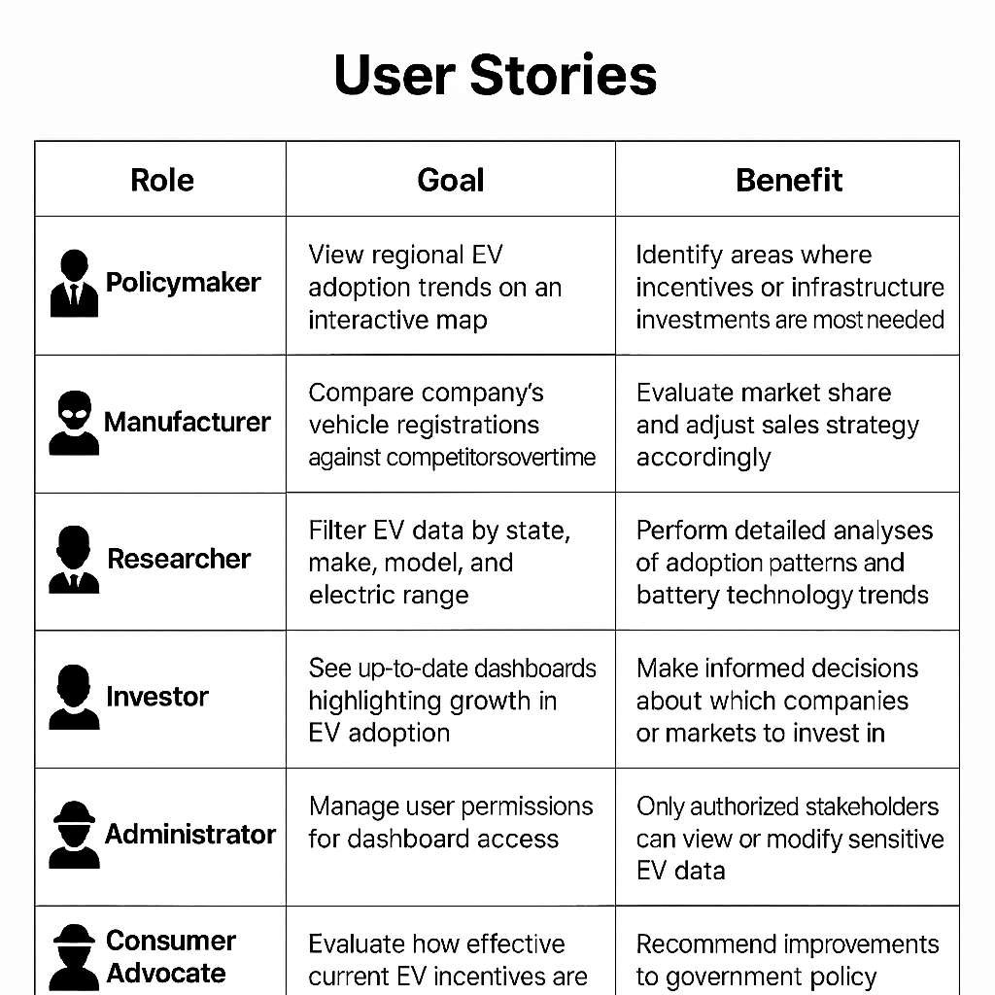

### TECHNOLOGY STACK

**Technical Architecture:**

The Electric Cars Analytics Dashboard uses a modern, reliable technology stack to ensure performance, scalability, and maintainability. Below are the key components of the stack:

📦 Data Sources

* + - Government Registration Databases — Official vehicle registration datasets with EV attributes (make, model, year, range, location).
    - Manufacturer Reports — Supplemental data on sales volumes and specifications.
    - Incentive Program Records — Information on eligibility for government EV incentives.

🗄 Data Storage & Processing

* + - Relational Database (e.g., PostgreSQL or MySQL) — Centralized storage of cleaned and transformed EV data.
    - ETL Tools (Extract, Transform, Load) — Python scripts or data pipelines scheduled via Airflow or cloud services to automate data ingestion, cleaning, and transformation.

📊 Data Visualization & Dashboard

* + - Tableau — The primary visualization tool for creating interactive dashboards with charts, maps, KPIs, and filters.
    - Tableau Server / Tableau Public — Deployment options for publishing the dashboard with secure access.

⚙ Backend & Integrations

* + - Python — For data preprocessing, calculations, and automation of ETL processes.
    - APIs (RESTful) — To connect external datasets or integrate real-time updates from registration databases.

🌐 Hosting & Deployment

* + - Cloud Platforms (e.g., AWS, Azure, or GCP) — Hosting the database, ETL pipelines, and Tableau Server instance.
    - SSL/HTTPS — Secure transmission of data between the dashboard and end users.

🖥 User Interface

* + - Responsive Web Interface (Tableau Embedded) — Allows stakeholders to access the dashboard on desktops, laptops, or tablets.

🔒 Security

* + - Role-Based Access Control (RBAC) — Controls who can view or modify the dashboard.
    - Data Encryption — Protects sensitive EV data during storage and transmission.

✅ Optional Tools

* + - Version Control (Git/GitHub) — Tracks changes to scripts and configuration files.
    - Monitoring Tools (e.g., CloudWatch, Prometheus) — Ensures performance, availability, and security of the deployed solution.

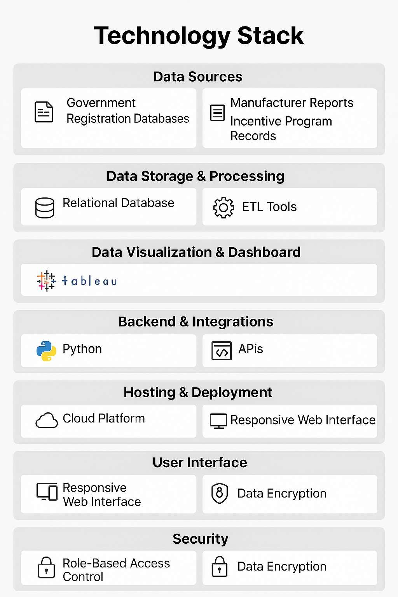

#### Application Characteristics:

###### Interactive Visualizations

* + Users can filter and explore data by brand, model, body style, price, and battery range.
  + Graphs, charts, and maps respond dynamically to selections.

###### User-Friendly Interface

* + Clean and intuitive dashboard layout.
  + Tooltips and labels help users understand data without technical expertise.

###### Data-Driven Insights

* + Aggregates key EV metrics (e.g., range, battery capacity, acceleration).
  + Helps users identify top-performing EVs based on specific needs (e.g., long range or low charging time).

###### Cross-Platform Accessibility

* + Hosted on Tableau Public, accessible via browsers on desktops and tablets.
  + No installation required—just a web link.

###### Real-Time Interaction

* + Dashboards update instantly as filters or parameters change.
  + Users can drill down into data at various levels (brand, year, country, etc.).

###### Lightweight Deployment

* + Requires only Tableau Public for hosting.
  + No backend server or complex deployment needed.

###### Scalable Design

* + Easily extendable with more data sources or KPIs.
  + Future datasets (e.g., sales, charging stations) can be integrated seamlessly.

###### Educational Utility

* + Useful for consumers, students, and policymakers exploring the EV market.
  + Supports data literacy through visual storytelling.

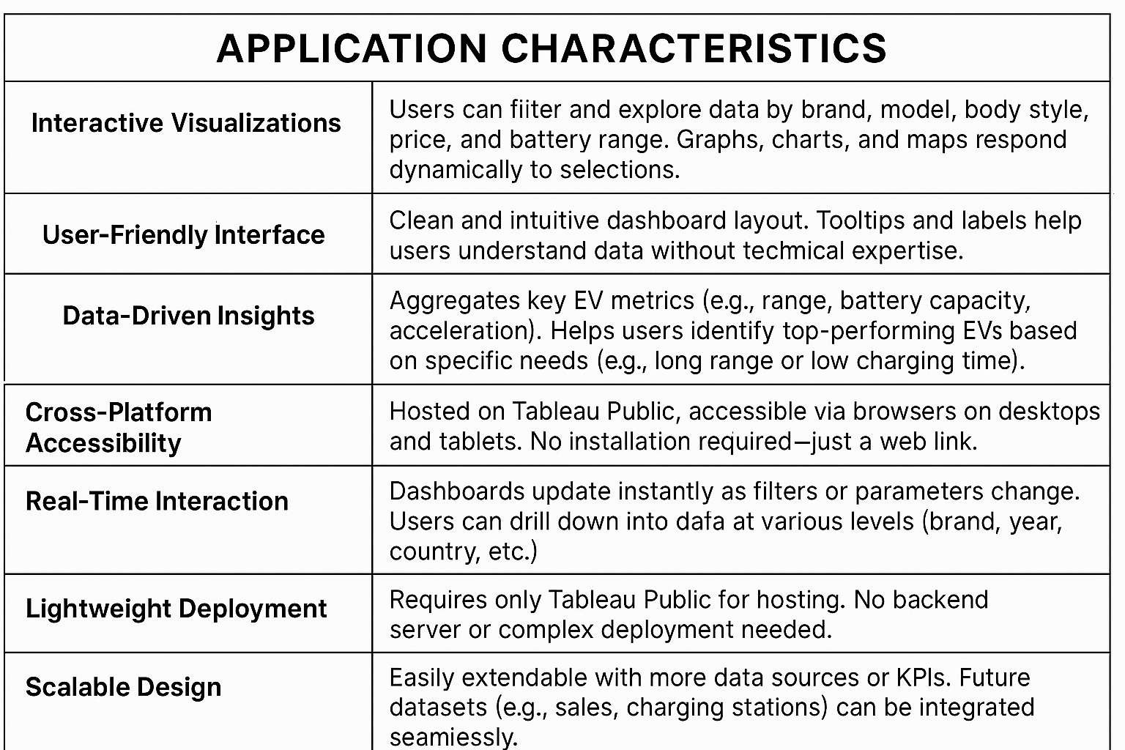

# PROJECT DESIGN

#### Problem – Solution Fit Template:

###### problem

Consumers, government agencies, and industry stakeholders face challenges in understanding the rapidly evolving electric vehicle (EV) landscape. Common problems include:

* + - Lack of accessible data comparing EV specifications.
    - Difficulty identifying vehicles that fit specific user needs (range, charging time, brand, etc.).
    - Insufficient data-driven insights to guide infrastructure and policy decisions.

###### Solution

An **interactive Tableau dashboard** was developed to bridge the information gap by:

* + - Providing a centralized, user-friendly platform to explore and compare EV data.
    - Visualizing key metrics such as battery range, price, charging time, and brand performance.
    - Allowing real-time filtering and interaction for deeper insight based on user priorities.

###### Fit Justification

* + - The dashboard meets the needs of **EV buyers** (to make informed purchase decisions), **environmental researchers** (for analyzing EV trends), and **planners or policymakers** (to assess infrastructure demands).
    - It eliminates manual comparison of specs and offers visually intuitive insights, improving decision-making.
    - The scalability and accessibility of Tableau Public ensure wide reach and usability without high technical barriers.

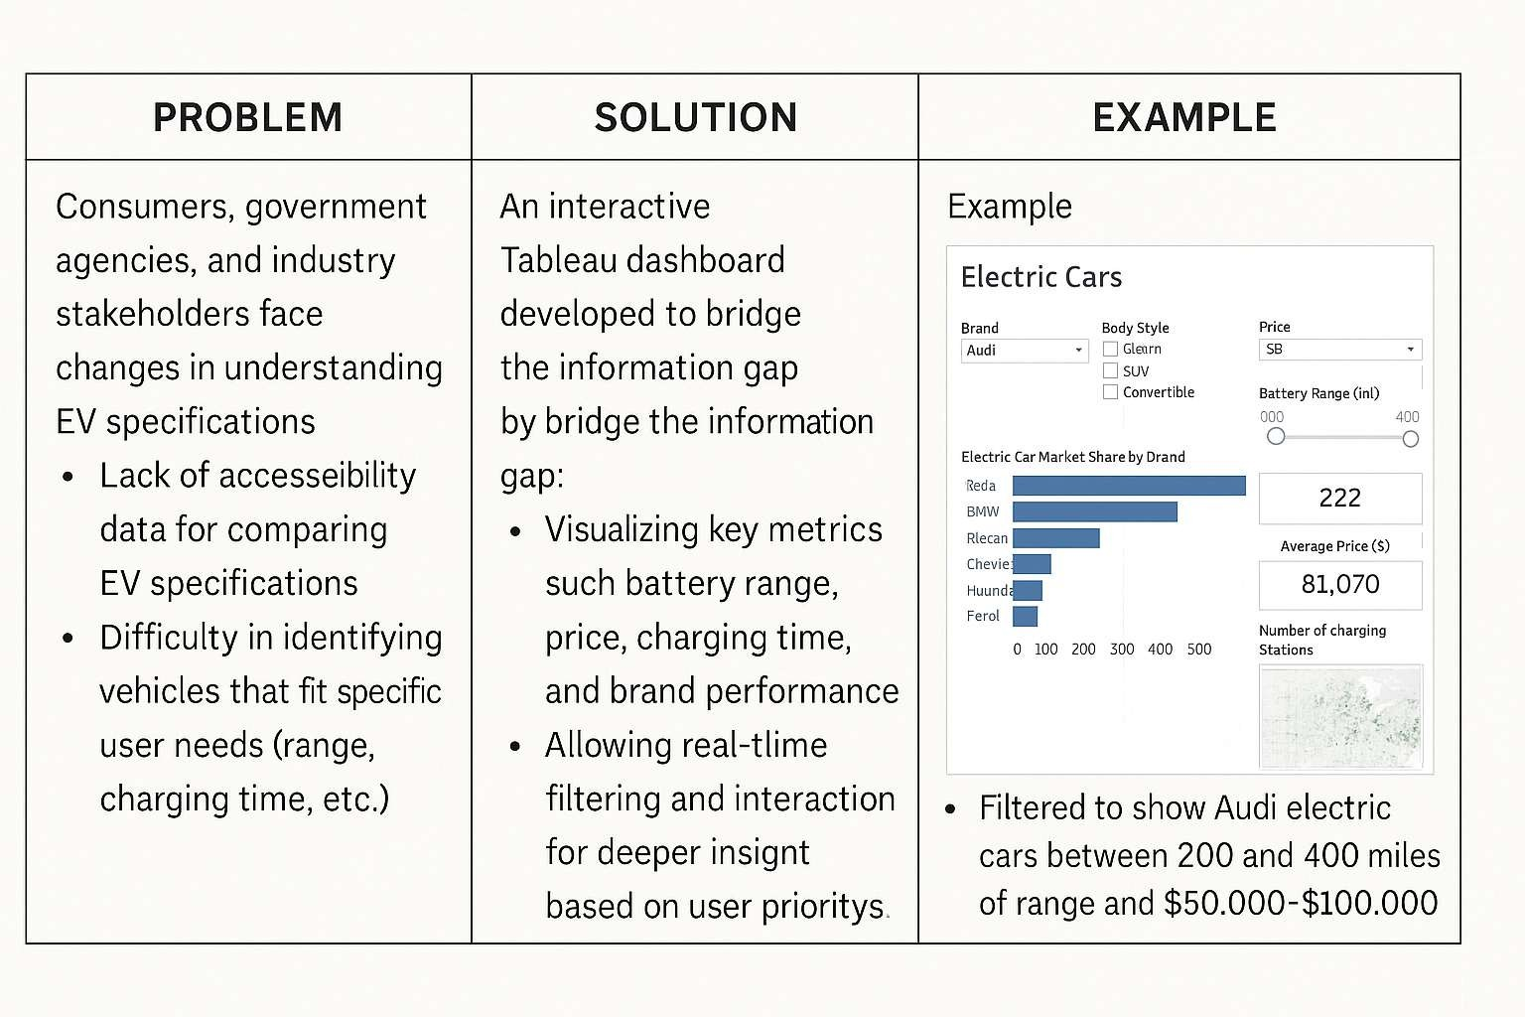

### PROPOSED SOLUTION

###### Proposed Solution Overview

To address the lack of accessible and comparative information on electric vehicles (EVs), an interactive Tableau-based dashboard is proposed. This solution focuses on presenting key EV metrics in an intuitive, filterable, and visually engaging format that helps users draw meaningful insights.

###### Key Features of the Solution

* + - Filterable Views by brand, body style, price, range, etc.
    - Visual Insights through bar charts, maps, and summary indicators.
    - Dynamic Dashboards with real-time interactivity.
    - Clean UI/UX suitable for technical and non-technical users.
    - Web-Accessible via Tableau Public—no software installation needed.

###### Benefits

* + - Enables data-driven decision-making for buyers and stakeholders.
    - Provides a comprehensive comparison of EV models and specifications.
    - Facilitates trend analysis over time and across brands.

|  |  |
| --- | --- |
| **Feature** | **Description** |
| Platform | Tableau Public |
| Data Inputs | EV dataset including brand, model, battery range, price, charging time |
| Main Visuals | Market share chart, battery vs price graph, filterable EV list, map |
| User Controls | Brand, price slider, battery range, body style filters |
| Access | Hosted online, accessible from any device with a browser |
| Goal | To simplify EV analysis and improve access to clean vehicle information |

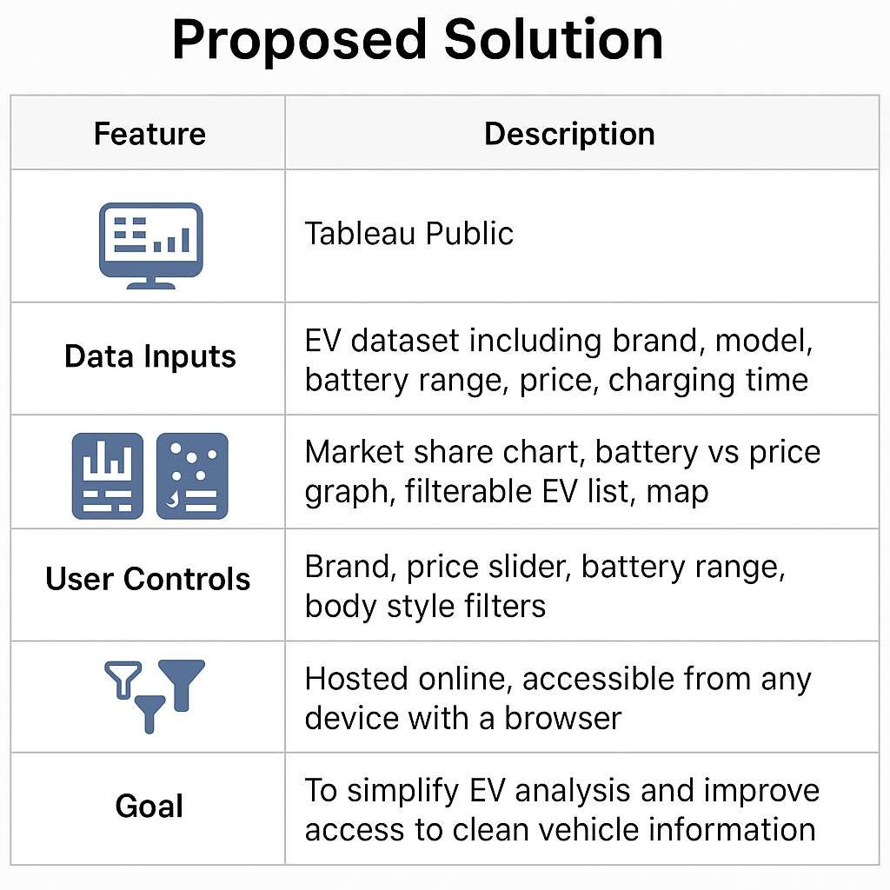

### SOLUTION ARCHITECTURE

The architecture of the Electric Cars Analytics project is structured into five layers that ensure a smooth flow from raw data to user interaction. The process begins with the data source, which consists of publicly available electric vehicle datasets stored in CSV or Excel formats.

These datasets include essential attributes such as brand, model, battery range, price, and charging time.

Once collected, the data moves to the processing layer, where tools like Microsoft Excel or Tableau Prep are used to clean, structure, and transform the information into a usable format. After preprocessing, the refined data is imported into Tableau Public for visualization. Within Tableau, the dashboard is developed using charts, graphs, filters, and maps to present the data in an insightful and interactive manner.

The completed dashboard is deployed on Tableau Public, making it accessible to users via a simple web link without requiring any installations or sign-ins. The final layer involves user interaction, where end-users can explore the dashboard by adjusting filters, reading tooltips, and viewing summarized insights, enabling real-time and personalized data analysis.

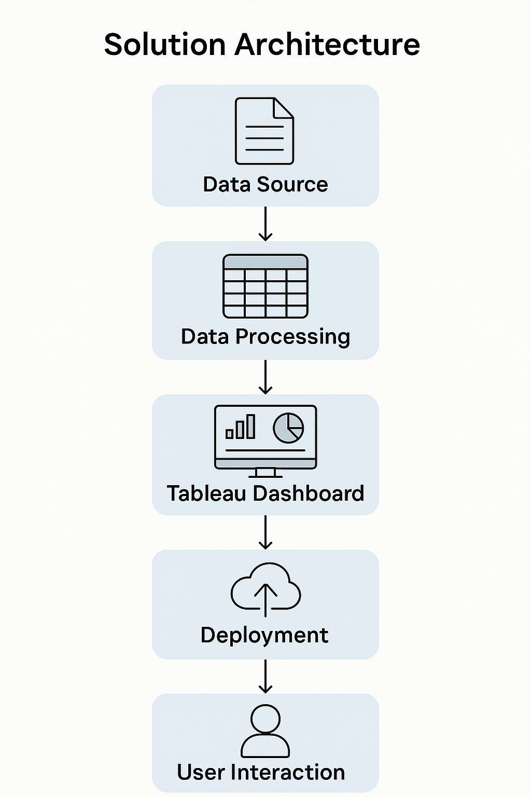

# PROJECT PLANNING AND SCHEDULING

### PROJECT PLANNING

The project starts with planning and scheduling to ensure smooth execution and timely delivery. It is divided into clearly defined, manageable stages that follow the Agile methodology. Each stage contributes to the successful development of an interactive Tableau dashboard focused on electric car analytics.

The project begins with collecting electric vehicle data from public sources. The data is then cleaned using Excel or Python for accuracy and consistency. Once cleaned, wireframes are developed to guide dashboard layout and visual storytelling. Visualizations are built in Tableau, tested for performance and usability, and refined based on feedback. Finally, all findings are documented and compiled for the final demo.

**Product Backlog**

|  |  |  |  |
| --- | --- | --- | --- |
| **User Story** | **Story Points** | **Sprint** | **Priority** |
| As a researcher, I want to collect EV data from public datasets | 3 | Sprint 1 | High |
| As a developer, I want to clean and prepare the EV dataset | 5 | Sprint 1 | High |
| As a designer, I want to design wireframes for dashboard layout | 3 | Sprint 1 | Medium |
| As a user, I want to explore electric car specs with filters | 8 | Sprint 2 | High |
| As a viewer, I want to compare brands by range and price | 5 | Sprint 2 | High |
| As a tester, I want to validate dashboard responsiveness | 4 | Sprint 3 | High |
| As a stakeholder, I want a final demo and documentation | 5 | Sprint 4 | High |

**Sprint Schedule (10-Day Sprint Duration)**

|  |  |  |
| --- | --- | --- |
| **Sprint** | **Dates** | **Tasks** |
| Sprint 1 | June 1 – June 10 | Data collection, cleaning, wireframes |
| Sprint 2 | June 11 – June 20 | Dashboard building in Tableau, filters, brand comparisons |
| Sprint 3 | June 21 – June 25 | Testing dashboard interactivity and data accuracy |
| Sprint 4 | June 26 – June 28 | Documentation, demo prep, final project submission |

**Velocity Calculation**

Assuming team velocity is **20 story points per sprint** and each sprint is **10 days**, the average velocity is:

Average Velocity (AV)=20 points10 days=2 points/day\text{Average Velocity (AV)} = \frac{20

\text{ points}}{10 \text{ days}} = 2 \text{ points/day}Average Velocity (AV)=10 days20 points

=2 points/day

###### Burndown Chart

|  |  |  |
| --- | --- | --- |
| **Day** | **Planned Work Remaining** | **Actual Work Remaining** |
| Day 0 | 20 | 20 |

|  |  |  |
| --- | --- | --- |
| **Day** | **Planned Work Remaining** | **Actual Work Remaining** |
| Day 2 | 16 | 17 |
| Day 4 | 12 | 13 |
| Day 6 | 8 | 9 |
| Day 8 | 4 | 4 |
| Day 10 | 0 | 0 |

*(You can visualize this as a line graph showing planned vs. actual work decreasing over time.)*

###### Presentation / Buffer Time

* **Date**: **June 30, 2025**
* **Event**: Final project presentation and dashboard demo
* **Deliverables**: Tableau dashboard, final report, GitHub/dataset links, demo video (if applicable)

Would you like me to now:

1. **Generate a burndown chart image**
2. **Visualize the sprint schedule as a timeline**
3. **Make a product backlog table image**

# FUNCTIONAL AND PERFORMNACE TESTING

### FUNCTIONAL TESTING

###### Data Accuracy

* + All charts reflect correct values from the dataset.
  + Calculated fields (e.g., price per sqft, property age) give expected results
  + Filters don’t break visuals or return incorrect values.

###### Chart Functionality

* + Bar chart changes dynamically with filter selections.
  + Line chart correctly plots trends over time.
  + Scatter plot updates based on selected features.
  + Map/heatmap shows accurate regional data.
  + Pie/donut charts reflect correct proportions.

###### Interactivity

* + Filters (location, year, property type) work without lag.
  + Tooltips show correct, complete, and readable data.
  + Clickable elements (e.g., drill-downs) work properly.
  + Hover interactions highlight correct elements.

###### User Navigation

* + All dashboard tabs or story points are accessible.
  + Navigation between views (if applicable) is smooth.
  + UI is clean and easy to understand for non-technical users.

###### Responsiveness

* + Dashboard displays correctly on desktop and tablet.
  + Visuals resize properly without cutting off content.
  + Filters and legends are not overlapping or hidden.

###### Performance

* + Dashboard loads within 5 seconds on Tableau Public.
  + No crashing or freezing during interaction.

###### Export & Sharing

* + PDF/Image exports retain visual clarity.
  + Shareable link to Tableau Public works correctly.
  + All visuals are properly titled and labeled.

#### Performance Testing

###### Dashboard Load Time

* + Dashboard loads within 3–5 seconds on Tableau Public.
  + No significant delay when opening or switching tabs/story points.
  + Test with different internet speeds (mobile hotspot vs Wi-Fi).

###### Filter Responsiveness

* + Applying filters (location, year, bedrooms, etc.) updates all charts quickly (≤ 2 seconds).
  + Multiple filters applied at once do not cause freezing or lag.
  + Changing filters several times doesn’t lead to crashing or incorrect visuals.

###### Chart Rendering Time

* + Charts (bar, line, map, scatter) render smoothly without delay or flickering.
  + Large dataset visualizations (e.g., heatmaps, highlight tables) do not slow down dashboard.

###### Interactivity Speed

* + Hover tooltips display immediately.
  + Click-to-drill (if enabled) responds within 1–2 seconds.
  + Story point navigation responds instantly.

###### Cross-Device Performance

* + Dashboard performs equally well on different screen sizes:
  + Desktop (preferred)
  + Tablet (optional check)
  + Layout adapts without misalignment or missing visuals.

###### Stress Testing

* + Dataset scaled up (double rows) to test performance with more data.
  + All charts still load within acceptable limits.

###### Publish & Share Test

* + Tableau Public link is accessible across different browsers (Chrome, Edge, Firefox).
  + Shared link opens without login requirement (if public).
  + Exported versions (PDF/Image) preserve layout and resolution.

# RESULTS

### OUTPUT SCREENSHOTS

##### DASHBOARDS:

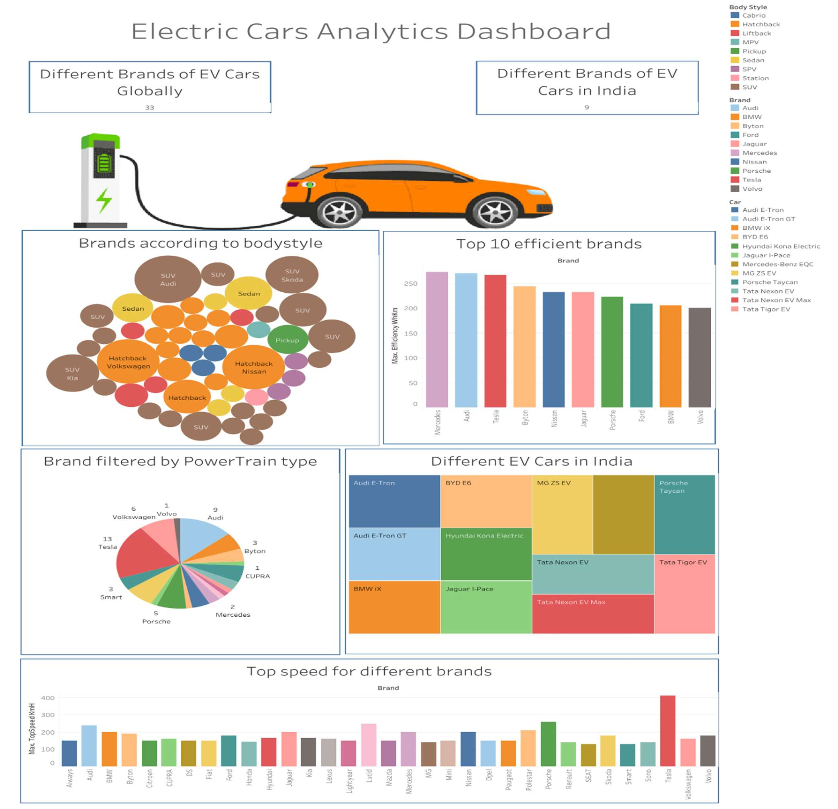

###### 🔍 Dashboard Highlights

* + - **33 global EV brands** and **9 Indian EV brands** analyzed.
    - **Bodystyle Distribution**: SUV is the most dominant body type across brands.
    - **Top Efficient Brands**: Mercedes, Audi, Tesla, and BYD lead in energy efficiency (Wh/km).
    - **Powertrain Analysis**: Tesla has the highest variety; Audi and Volkswagen follow.
    - **Indian EV Market View**: Tata Nexon EV, MG ZS EV, and Porsche Taycan among key players.
    - **Top Speed Comparison**: Tesla leads with over **400 km/h**, followed by Lucid and Porsche.

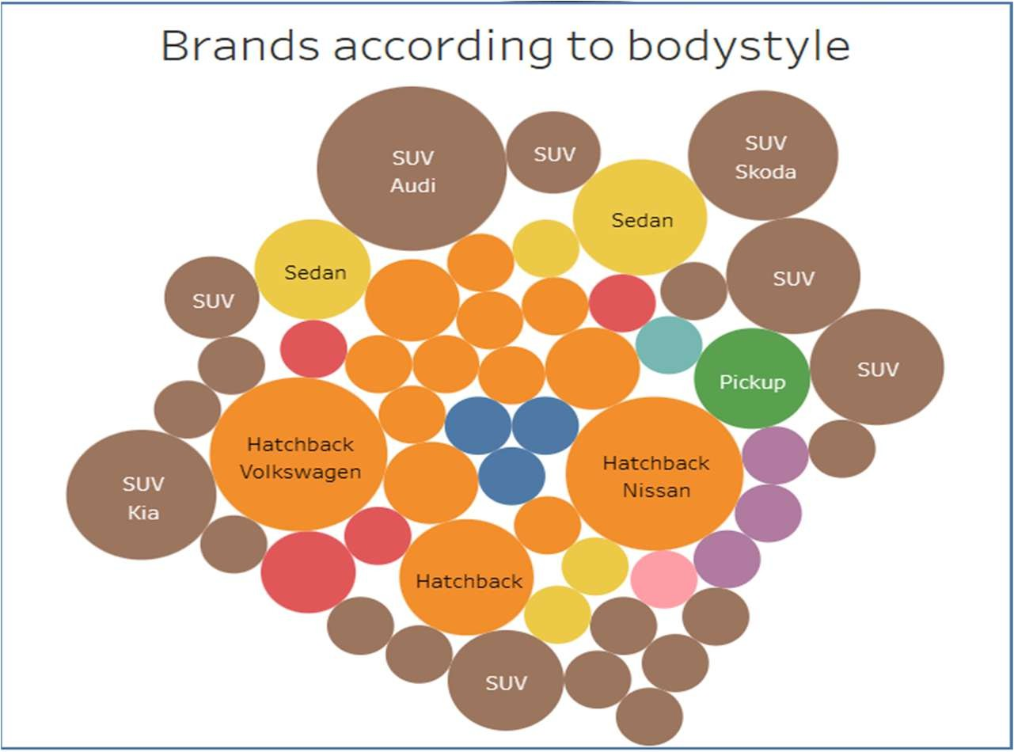

Visualizes electric vehicle brands based on their **body style categories** such as **SUV**, **Hatchback**, **Sedan**, and **Pickup**.

###### ✅ Insights:

* + - **SUVs dominate** the EV market, with prominent contributions from **Audi**, **Skoda**, and **Kia**.
    - **Hatchbacks** are also widely represented, especially by **Volkswagen** and **Nissan**.
    - **Sedans** appear as mid-size entries, with fewer large bubbles compared to SUVs and hatchbacks.
    - **Pickup trucks** remain a minority, indicating lower representation in current EV lineups.

###### 🔍 Interpretation:

The **size of each bubble** represents the number of models or prominence of the brand within that body style. Larger bubbles imply higher representation or market weight.

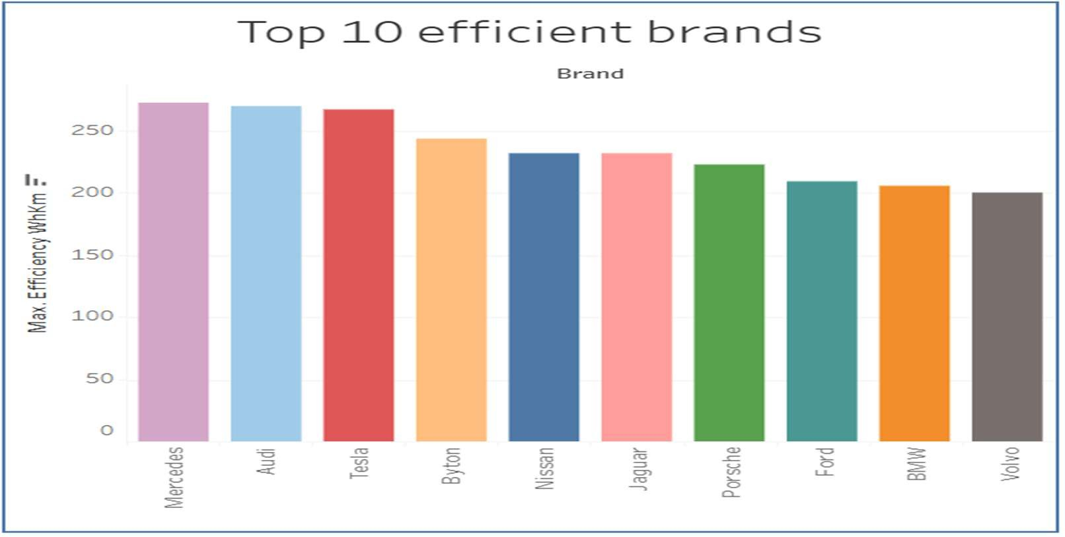

Ranks the top 10 electric vehicle brands based on their **maximum efficiency measured in Wh/km (watt-hours per kilometer)** — a lower consumption indicates higher energy efficiency.

###### ✅ Insights:

* + - **Mercedes, Audi, and Tesla** lead in electric vehicle efficiency, each exceeding **260 Wh/km**.
    - Emerging brand **Byton** ranks impressively in 4th place, ahead of Nissan and Jaguar.
    - Traditional performance brands like **Porsche** and **BMW** show balanced efficiency.
    - **Volvo** rounds out the top 10 with just over **200 Wh/km**.

###### 🔍 Interpretation:

These values represent the **maximum efficiency achieved** by any model within each brand's EV lineup. Brands that top the list combine energy optimization with advanced battery technology.

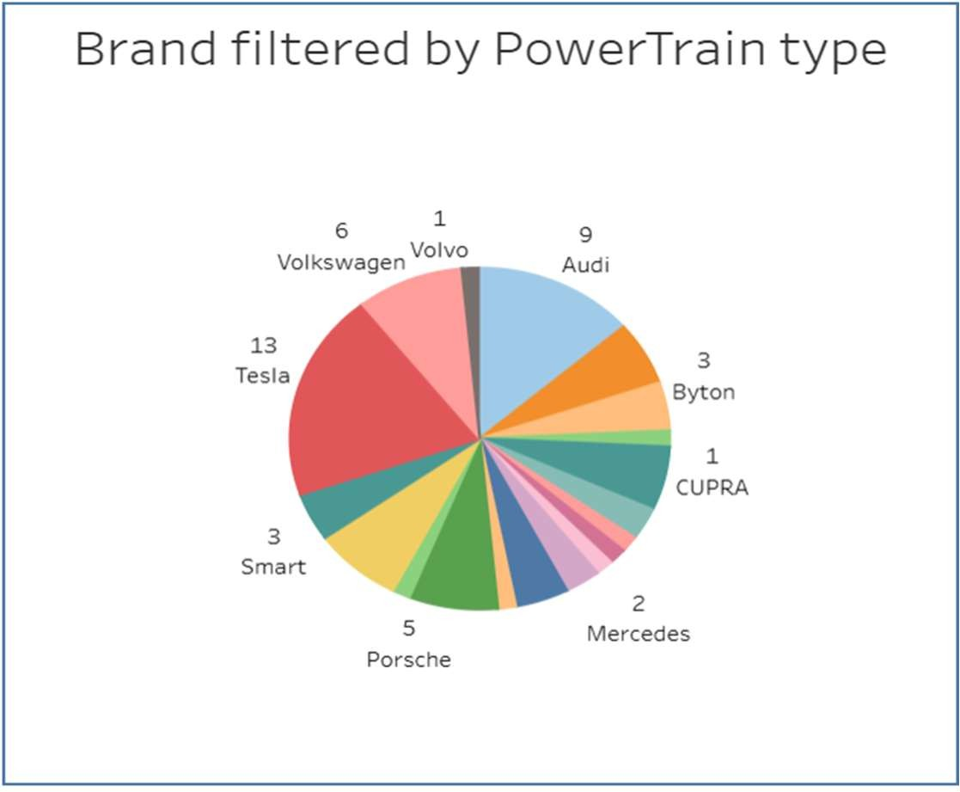

Illustrates the number of electric vehicle models by brand, filtered specifically by their

###### PowerTrain configuration.

✅ **Insights:**

* + - **Tesla** dominates with **13 models**, showcasing its leadership in powertrain diversity.
    - **Audi** follows with **9 models**, indicating a strong lineup of EV configurations.
    - **Volkswagen (6)**, **Porsche (5)**, and **Smart (3)** show balanced contributions.
    - Brands like **Volvo, CUPRA**, and **Mercedes** contribute with fewer but specialized models.

###### 🔍 Interpretation:

The chart reflects each brand’s commitment to diverse electric powertrain options, with Tesla clearly leading the innovation curve in drivetrain variations.

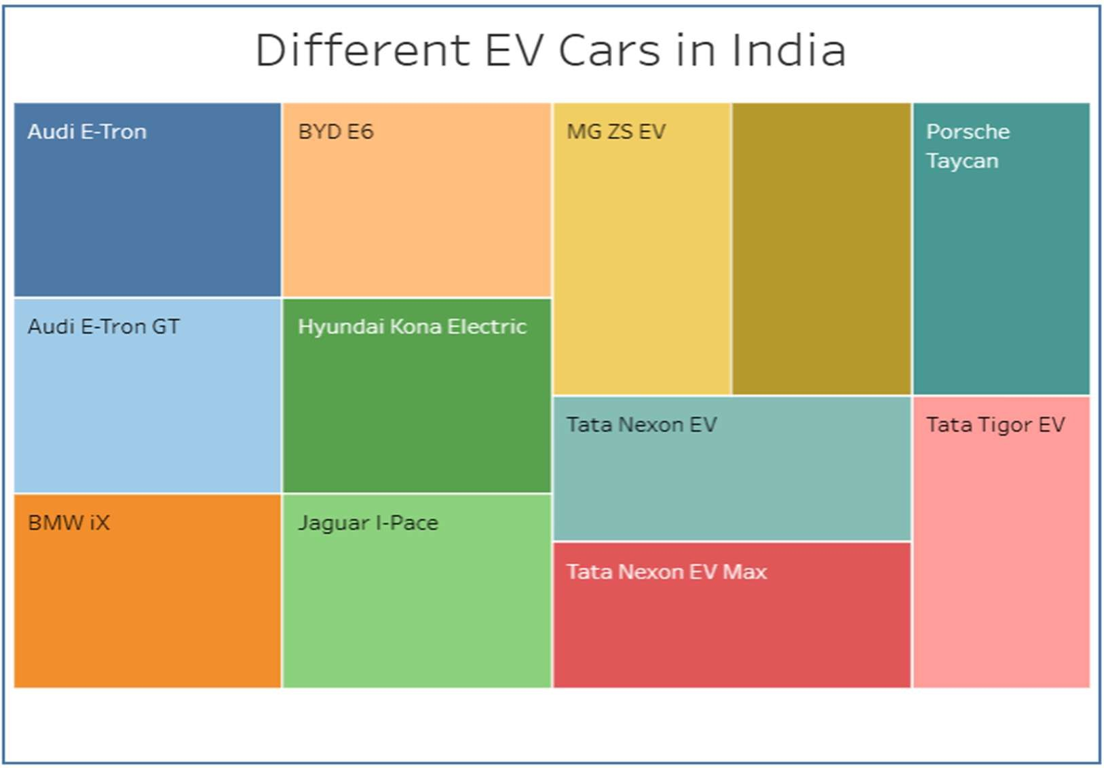

Displays a variety of electric vehicle models currently available in the Indian market. The size of each block reflects the model's relative presence or market visibility.

###### ✅ Insights:

* + - **Tata Motors** leads with three major models: **Tata Nexon EV**, **Tata Nexon EV Max**, and **Tata Tigor EV**.
    - Premium international brands like **Audi**, **BMW**, **Jaguar**, and **Porsche** are also represented, indicating India's growing premium EV market.
    - Mid-range options include **MG ZS EV**, **BYD E6**, and **Hyundai Kona Electric**.

###### 🔍 Interpretation:

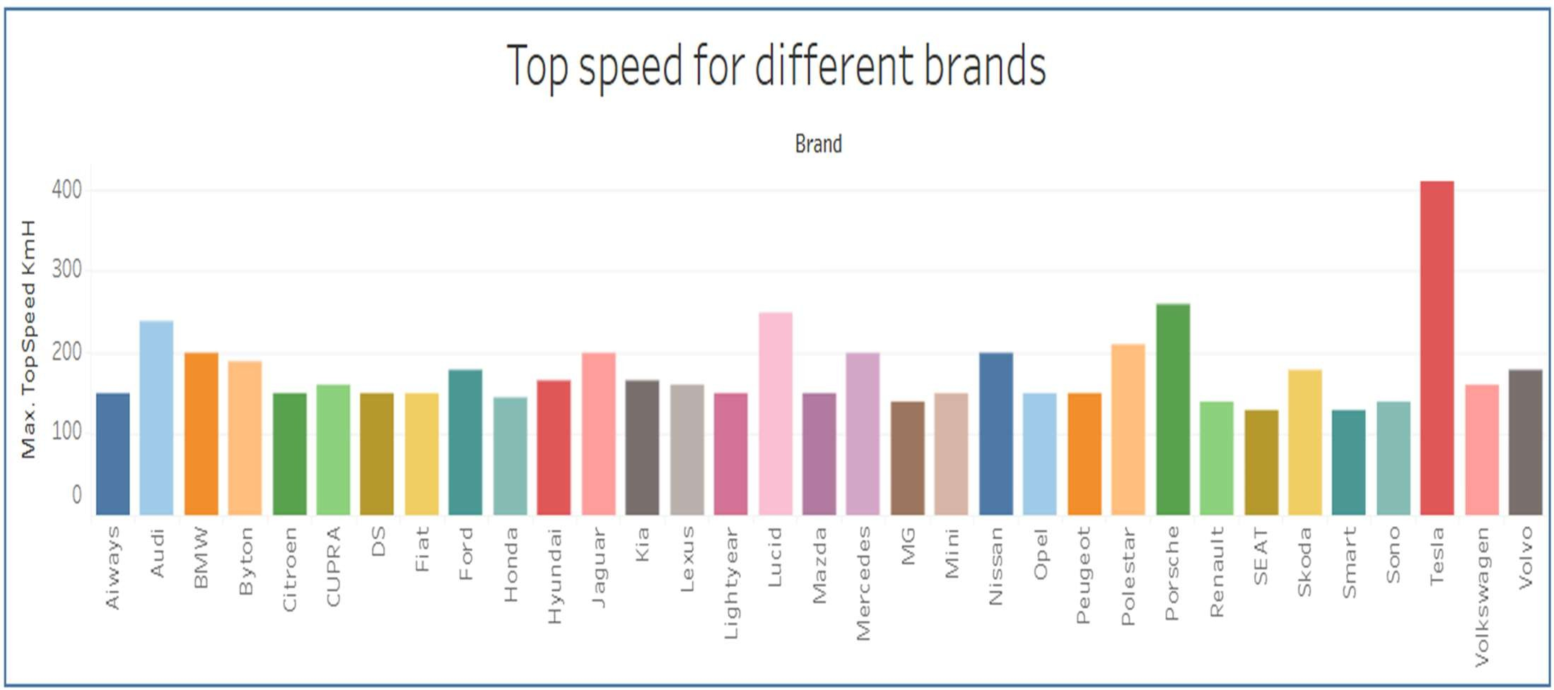This chart emphasizes the **diversity and segmentation** within India’s EV space — from **affordable domestic vehicles** to **luxury international imports**, demonstrating the country’s expanding electric vehicle adoption.

Illustrates the **maximum top speed (km/h)** achieved by electric vehicle models across different brands. It provides insights into the performance capability of each manufacturer’s fastest EV.

###### ✅ Insights:

* + - **Tesla** leads all brands with a maximum top speed **exceeding 400 km/h**, highlighting its performance-focused engineering.
    - **Lucid** and **Porsche** follow with top speeds over **250 km/h**, solidifying their premium performance standing.
    - Mid-range speeds (180–220 km/h) are common among brands like **Audi**, **Jaguar**, **BMW**, and

###### Polestar.

* + - More economical brands such as **Smart**, **Citroen**, and **SEAT** exhibit lower top speeds (around 140–160 km/h), optimized for city driving.

###### 🔍 Interpretation:

This chart reflects the diverse **performance priorities** across brands — from luxury and speed (Tesla, Porsche) to practicality and efficiency (Smart, Citroen). It visually emphasizes how **brand identity** influences vehicle design and engineering direction in the EV market.

**STORY:**

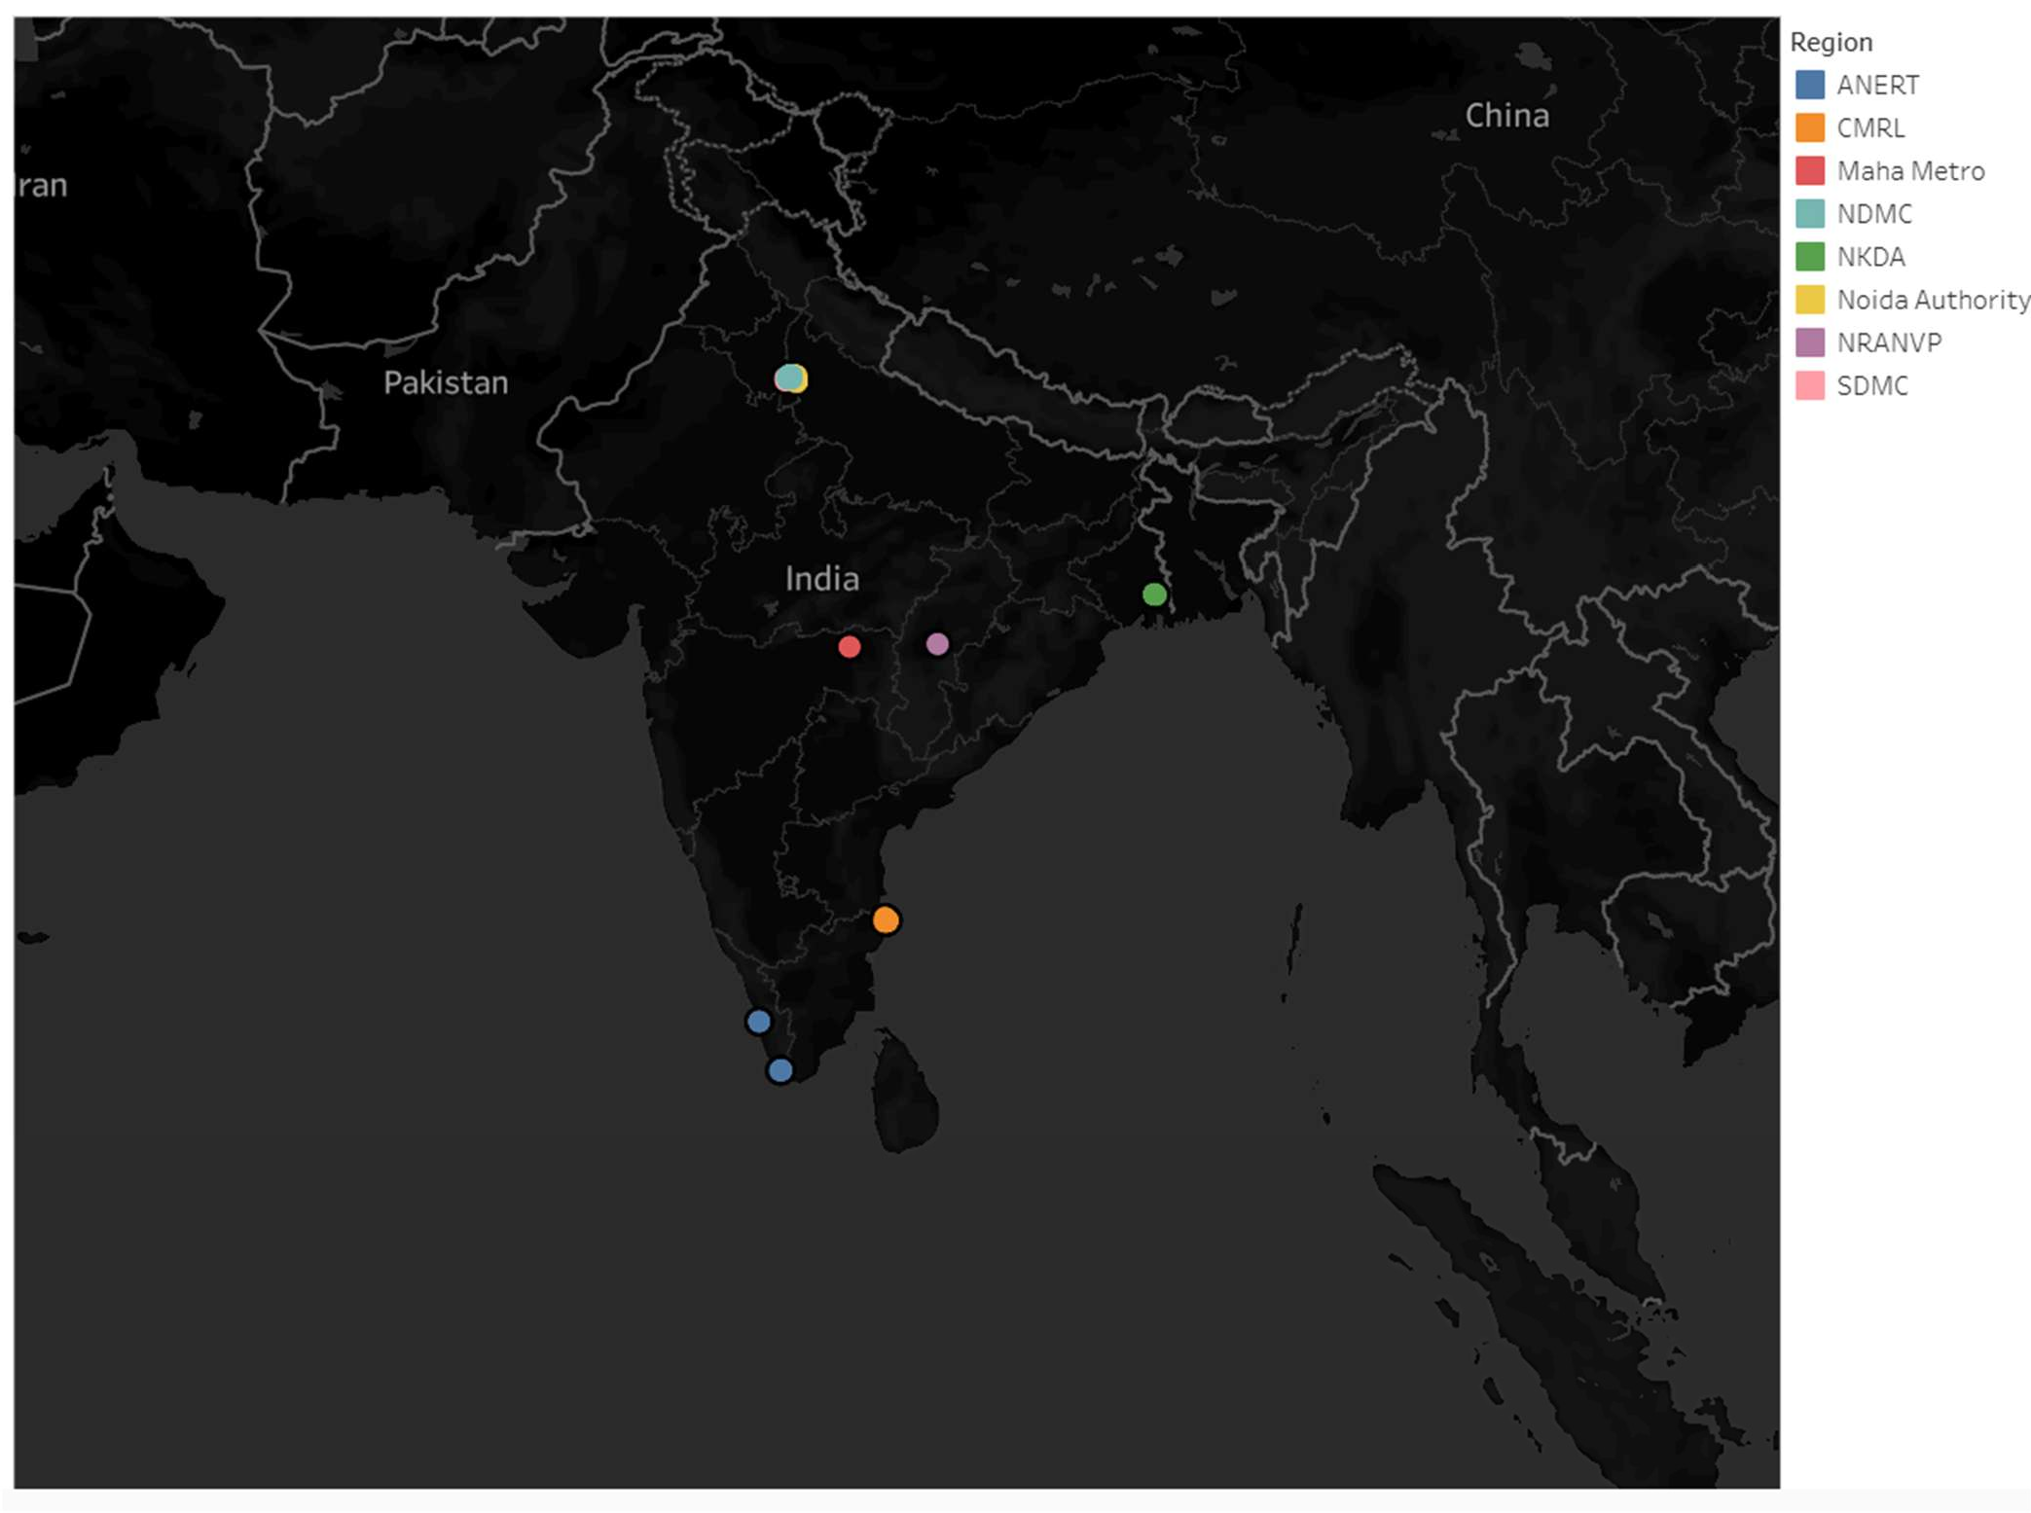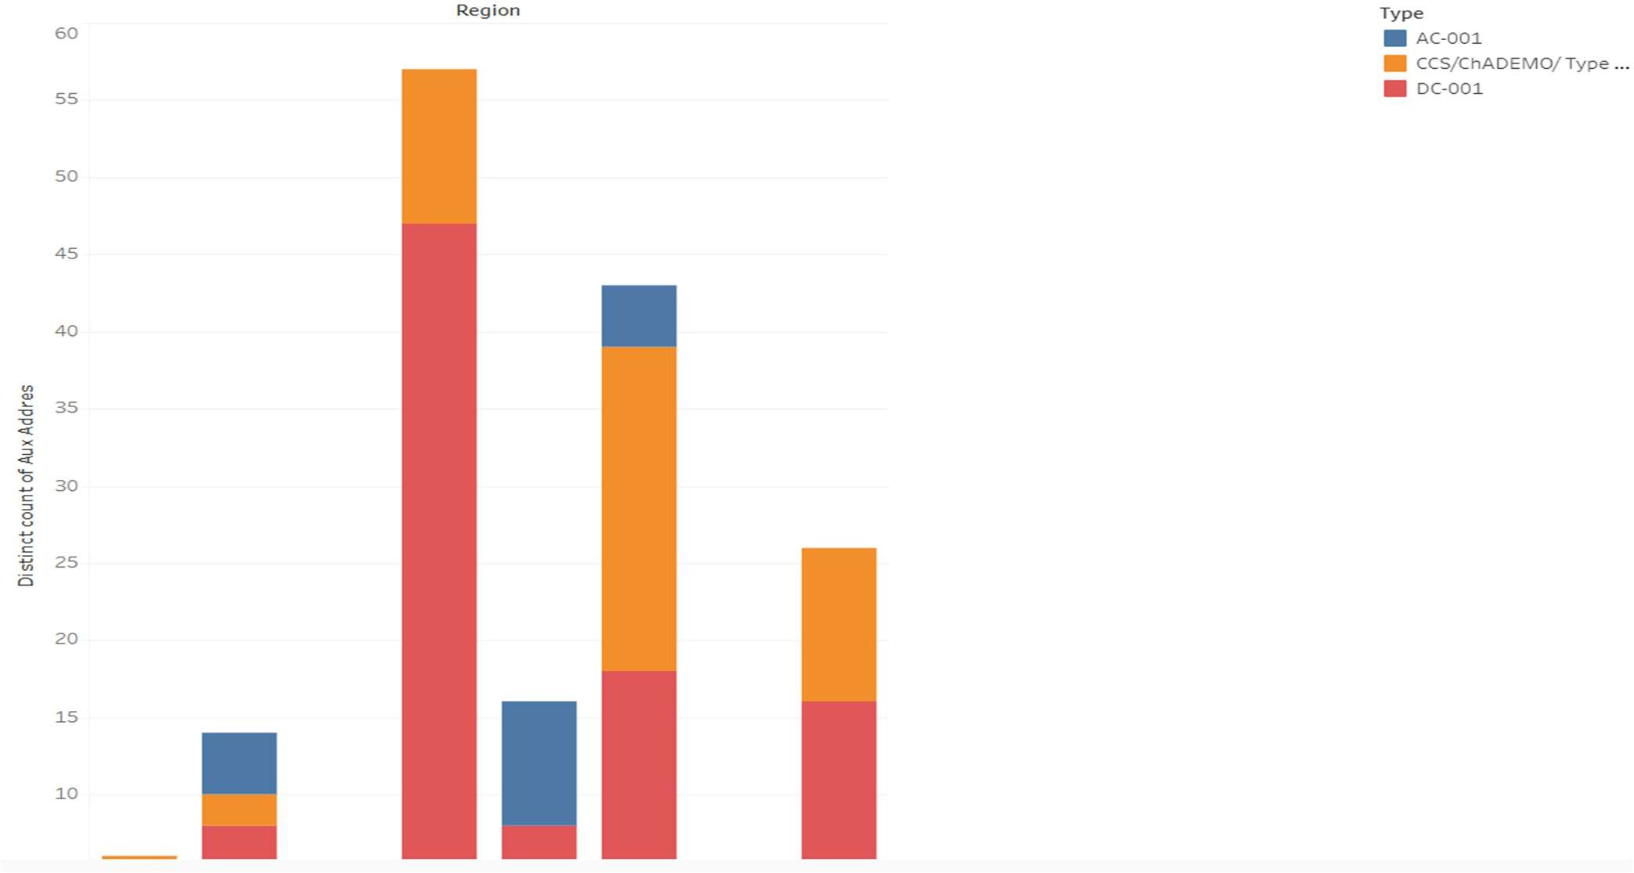

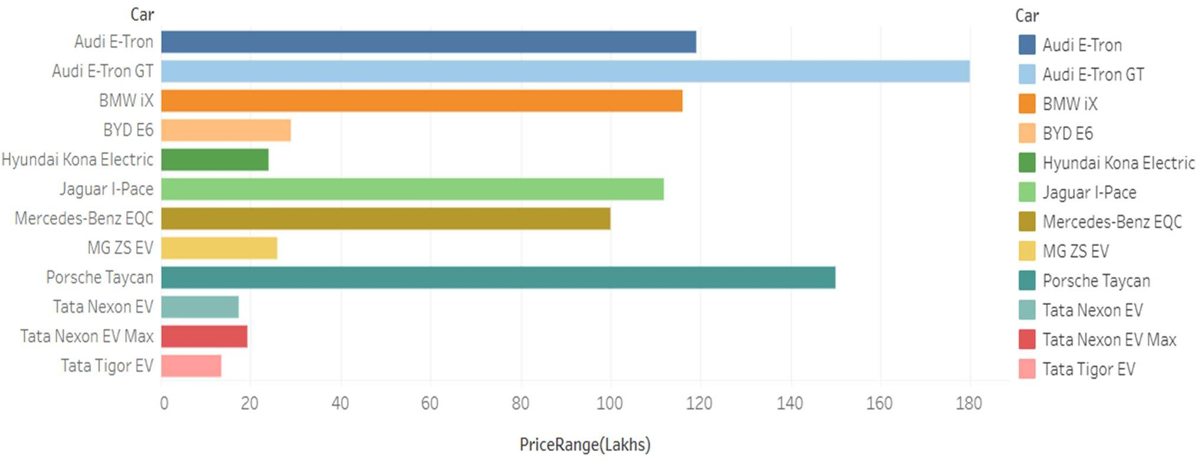

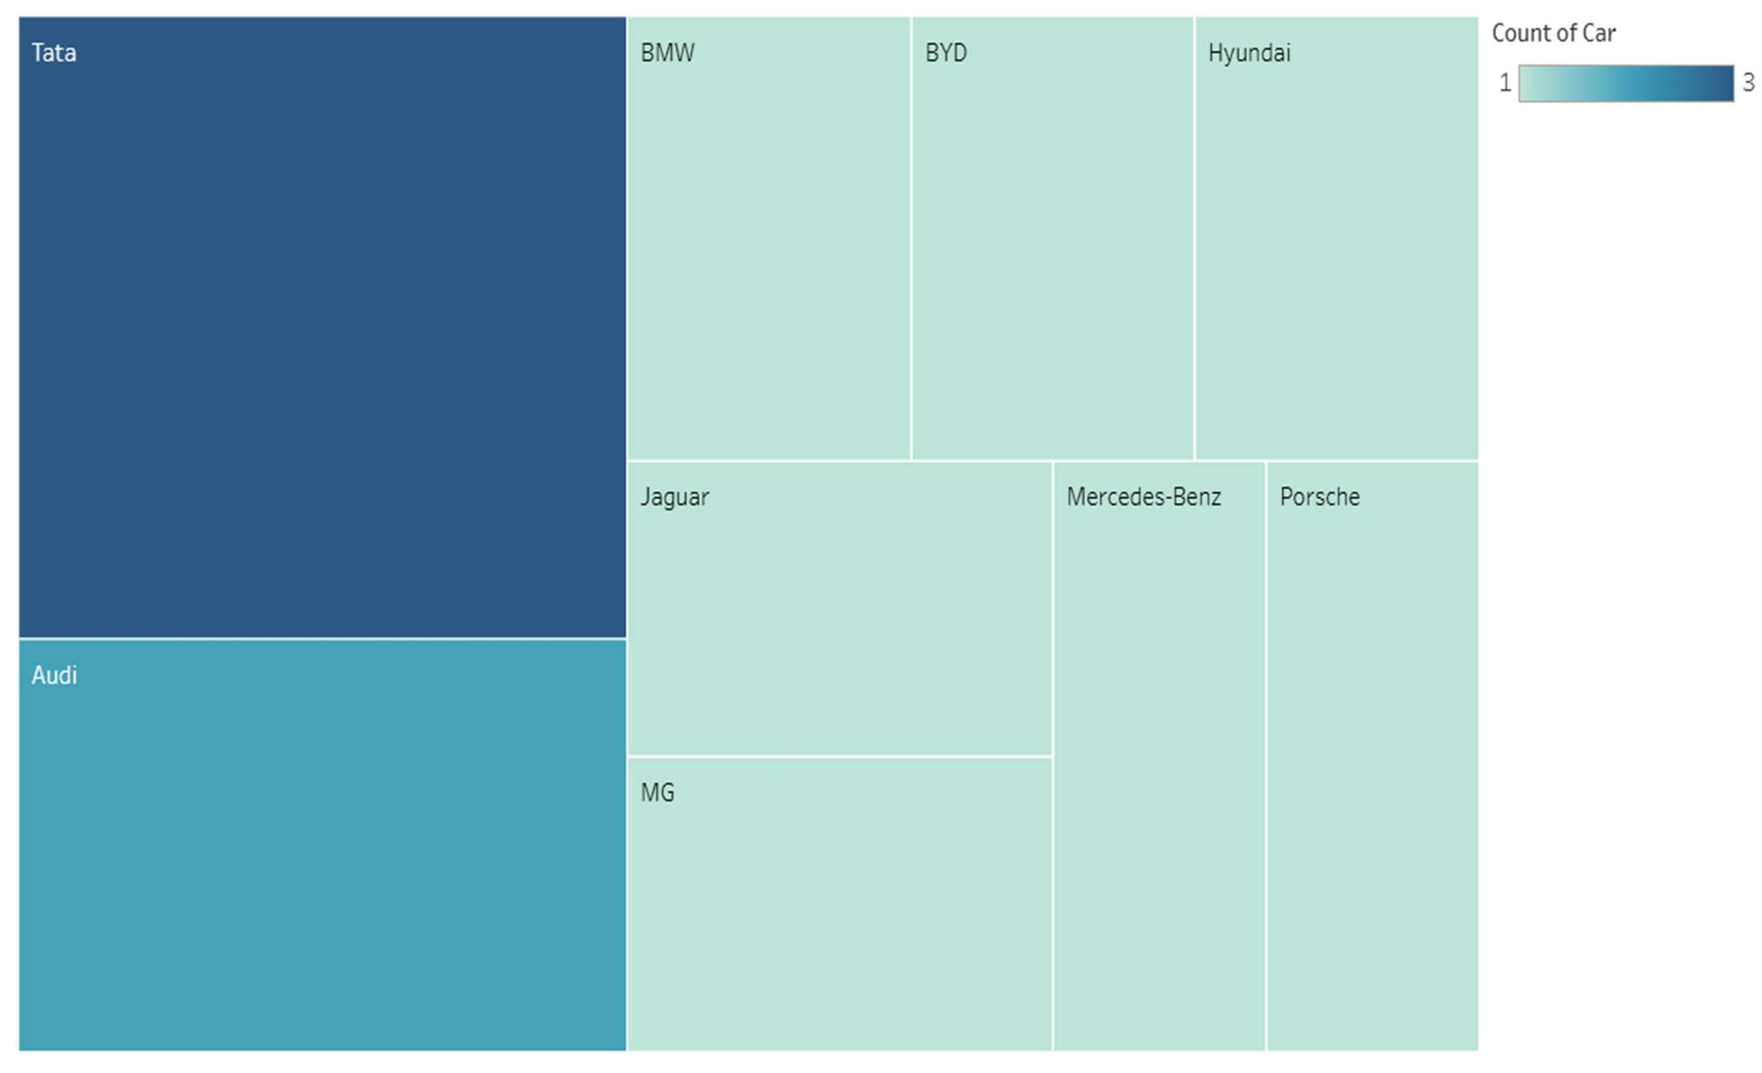

# ADVANTAGES AND DISADVANTAGES

## Advantages:

###### ✅ 1. Interactive Visualization

The dashboard provides a user-friendly, filterable interface that allows users to explore electric vehicle data by brand, range, body style, and price range with real-time responsiveness.

###### ✅ 2. Comparative Analysis Made Simple

Users can quickly compare EV models and brands based on performance, efficiency, speed, and body style, eliminating the need for manual data comparison.

###### ✅ 3. Clear Insights for Stakeholders

The dashboard enables potential EV buyers, manufacturers, and policymakers to make informed decisions using key metrics like battery range, powertrain type, and charging performance.

###### ✅ 4. Data Accessibility

Built using Tableau Public, the dashboard is accessible online from any device, with no login or software installation required.

###### ✅ 5. Customizable and Scalable

New data sources, metrics, or visualizations (e.g., charging stations, CO₂ savings) can be added without changing the core structure.

###### ✅ 6. Real-Time Filtering

Instant updates on visual outputs make the dashboard highly interactive and dynamic, which enhances user engagement.

###### ✅ 7. Suitable for Technical and Non-Technical Users

The clean layout and visual storytelling make the dashboard intuitive for both data analysts and general public users.

## Disadvantages:

###### ⚠ 1. Limited Real-Time Data Integration

The dashboard uses static datasets. Without live connections to data sources (e.g., APIs), it lacks real-time updates on pricing or newly launched models.

###### ⚠ 2. Platform Dependency

Tableau Public is required for dashboard hosting and visualization. Offline access or local deployment without Tableau is not possible.

###### ⚠ 3. Data Size Limitations

Large or complex datasets may exceed Tableau Public’s upload limits, restricting scalability for enterprise-level data analytics.

###### ⚠ 4. Limited Backend Processing

Advanced data processing (e.g., machine learning, predictive modelling) cannot be directly implemented within Tableau itself—it requires external tools.

###### ⚠ 5. Internet Requirement

Since the dashboard is hosted on Tableau Public, users must have a stable internet connection to access and interact with it.

###### ⚠ 6. Aesthetic Constraints

Customization options in Tableau Public are limited compared to fully coded dashboards (e.g., using Power BI with DAX or custom JS/HTML).

# CONCLUSION

The Electric Cars Analytics Dashboard project exemplifies the effective use of data visualization to interpret complex datasets and present them in a user-friendly, accessible, and insightful format. By leveraging Tableau Public as the core visualization tool, the project brings together diverse electric vehicle data points — including brand, body style, top speed, powertrain types, price, range, and efficiency — into a unified platform that enables intuitive exploration and comparison.

This dashboard not only highlights current trends in the EV market but also uncovers hidden insights through interactive charts and graphs. For example, it reveals that SUVs dominate global EV body styles, Tesla leads in both powertrain diversity and top speed, and Tata Motors has made significant progress in the Indian EV market. Through dynamic filters and clean visual layouts, the dashboard ensures that users can focus on what matters to them — whether it's identifying the most energy-efficient brand, analysing the availability of EV models in a specific region, or evaluating performance metrics like acceleration and charging time.

The platform is designed with accessibility in mind. It requires no advanced technical expertise to operate and is accessible from any device with internet access via Tableau Public. This makes it ideal for a wide range of stakeholders — consumers researching EVs, analysts evaluating market share, developers benchmarking models, or government bodies tracking electrification progress.

From a project management perspective, the dashboard was developed using Agile methodology with clear sprints, velocity tracking, and a burndown chart to ensure time-bound and deliverable-driven execution. Each sprint was dedicated to a key phase — data gathering, preprocessing, dashboard design, testing, and final presentation — ensuring the project was well- paced and collaborative.

More importantly, this project proves the value of **data-driven storytelling** in supporting sustainable choices. As the automotive industry shifts towards electrification, tools like this dashboard can play a pivotal role in helping users understand their options, make informed decisions, and contribute to a greener future.

In conclusion, the Electric Cars Analytics Dashboard is not just a visualization project — it is a step toward democratizing access to meaningful, real-time insights in the rapidly growing electric mobility sector. With its adaptability and scope for future enhancements, the solution stands as a strong example of how data science and visualization can influence real-world behavior and policy.

# FUTURE SCOPE

The current version of the Electric Cars Analytics Dashboard offers a strong foundation for exploring electric vehicle data through visualization. However, there are several promising directions in which this project can be expanded to improve its utility, depth, and real-world impact.

###### 🔄 1. Real-Time Data Integration

Integrating real-time APIs from car manufacturers, EV sales platforms, or government data portals would allow users to view the most up-to-date statistics on EV prices, availability, battery specs, and charging station locations.

###### 🌍 2. Charging Infrastructure Mapping

Adding geolocation-based maps showing the distribution of EV charging stations across countries or cities (using APIs like OpenChargeMap) would make the dashboard more practical for route planning and infrastructure assessment.

###### 📈 3. Sales and Adoption Trends

Including time-series data to visualize sales volumes over the years, market adoption rates, and forecasts for future growth would enhance the dashboard’s analytical depth.

###### ⚡ 4. Environmental Impact Metrics

Incorporating sustainability indicators such as **CO₂ savings**, **electricity consumption per km**, or **lifecycle emissions** would help users assess the ecological benefits of switching to EVs.

###### 🔧 5. Advanced Analytics Integration

Using tools like Python, R, or Tableau Extensions to integrate **predictive modeling**, **clustering**

(e.g., by buyer preferences), or **machine learning** could add intelligent insights to the dashboard.

###### 👤 6. User Personalization

Enabling custom profiles or saving preferences within the dashboard could help repeat users view results tailored to their budget, driving needs, and location.

###### 🗺 7. Global vs Regional Dashboards

Splitting the dashboard into global, country-level, and city-level views would allow localized analysis — especially helpful for governments or urban planners.

###### 📱 8. Mobile Optimization

Optimizing the dashboard layout for mobile and tablet users would enhance usability, especially for users on the go or in dealerships.

###### 🤝 9. Integration with EV Dealerships

Partnering with EV dealerships to embed live inventory or promotional offers could make the dashboard commercially useful as a decision-support tool.